Password and Logon to the SWIC Web Server

Take Note:
[For Viewing] SWIC Web Server Address: http://webdivbus.swic.edu/{User Name}
i.e. http://webdivbus.swic.edu/doej0000

First Time Logon to the SWIC server: [Must start here]
[Also Used to Change Password!]
Connect to: http://webdivbus.swic.edu/{User Name}
i.e. http://webdivbus.swic.edu/doej0000
Enter your User Name [Given to you by your Instructor].
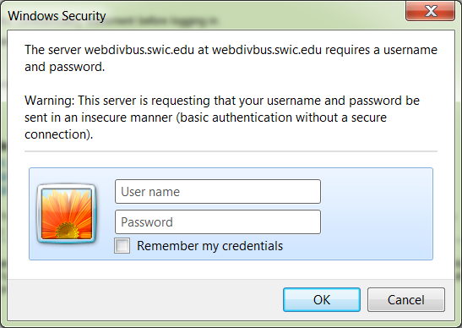

Enter password for Old password.

Twice, enter your new password [it must be at least 8 characters long].

Then Click OK.

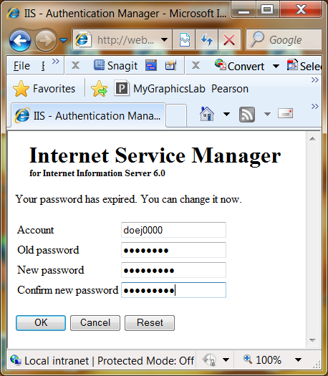

Your screen looks like this:

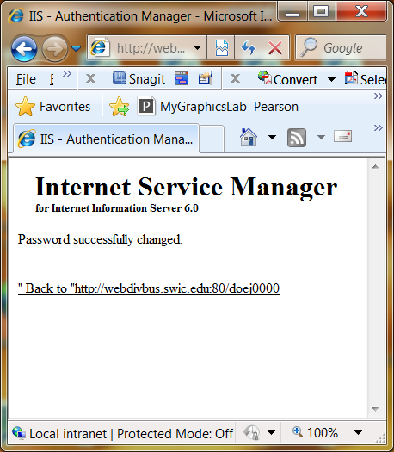

If you have problems contact your Instructor.

